**Exploring More Modules**



# Debugging in Node.js

Debugging is the process of finding and fixing errors or issues in your code.

It is essential for understanding and improving the functionality of applications.

Debugging in Node.js differs from JavaScript debugging in the browser.

Now, let's look at an example. Consider the following script, products.js:

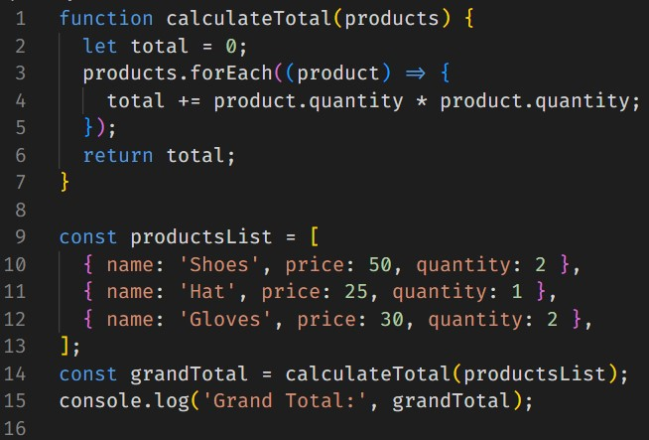

In this example, we have a small typo in the calculateTotal function.

Let's use the Node.js debugger to find the issue:

1. Run the command node inspect products.js

in your terminal.

1. In the debugger, set a breakpoint at line 4 using the command setBreakpoint(4)
2. Continue the execution using the command cont
3. When the breakpoint is hit, add a watch expression for the product variable using the command watch('product')
4. Also, add a watch expression for the total variable using the command watch('total')
5. Now, step over the next break point using the command cont
6. The watch expressions will now show the values of product and total. It is evident that there is an error in the code where product.quantity * product.quantity is used instead of product.price * product.quantity

## How debugging in Node.js is different than in Browser

As we mentioned earlier, debugging Node.js is different from debugging JavaScript in the browser. Here are some key differences:

* Environment: Node.js runs JavaScript in a server-side environment, whereas browser typically runs in the client side.
* Debugging tools: Node.js has its built-in debugger, while browser relies on browser-based tools like Chrome DevTools.
* Access to server-side resources: When debugging Node.js, you have access to server-side resources like the file system, databases, and network connections.
* Despite these differences, the core principles of debugging remain the same – finding and fixing issues in your code.

# Debugging in VS Code

We have discussed debugging Node.js applications using the built-in Node.js debugger. Now we'll explore debugging Node.js applications using Visual Studio Code (VSCode), a powerful code editor.

## Debugging Process in VS Code

To debug Node.js applications in VS Code:

* Open the products.js file in VS Code.
* Go to the Run and Debug panel or press Ctrl+Shift+D and click "create a launch.json file".

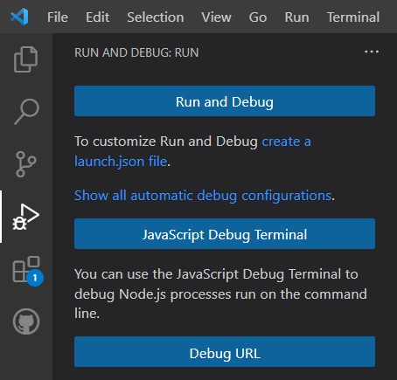

* Select "Node.js" from the dropdown to create a basic configuration for debugging Node.js applications.

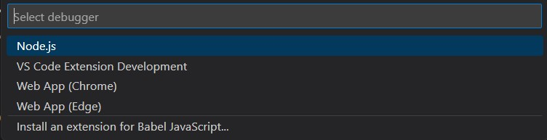

* Set a breakpoint at line 4 by clicking on the left side of the line number.

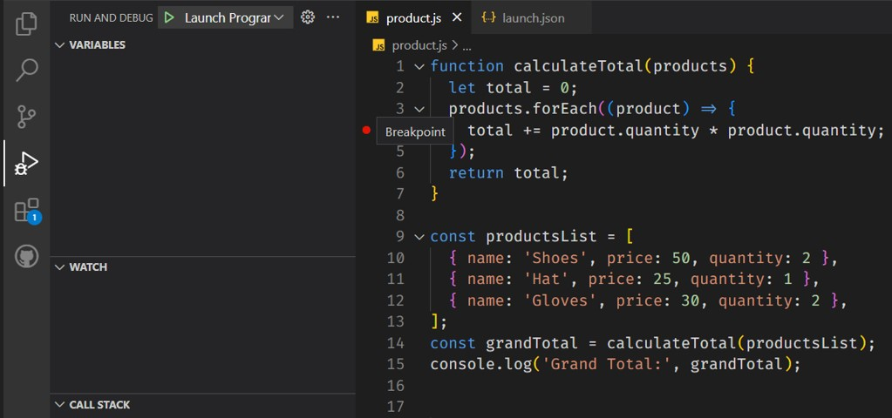

* Click the green "Launch Program" button or press F5 to start the debugger.



* Add the product and total variables to the watch panel to monitor their values.

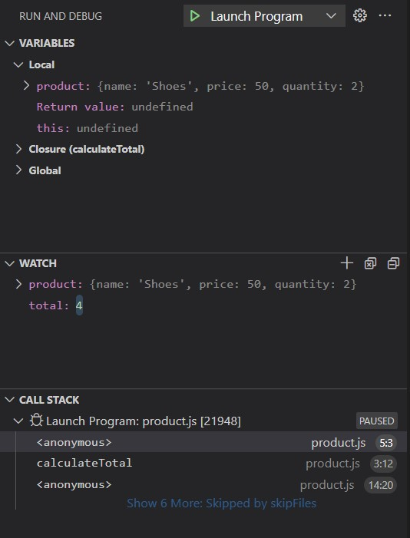

* The debugger will pause at the breakpoint, allowing you to inspect variables, step through code, and observe the call stack.

**VS Code offers several debugger options to control the debugging process:**

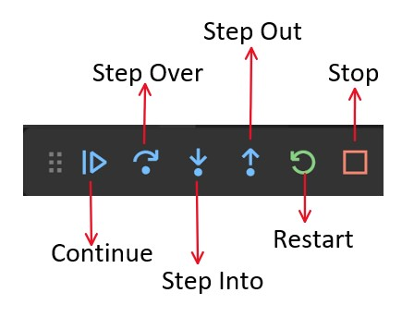

* **Continue**: This option allows the debugger to continue running the code until the next breakpoint or the end of the program is reached.
* **Step Over**: With this option, the debugger moves to the next line of code, skipping over function calls. It is useful for quickly moving through code without diving into function details.
* **Step Into**: This option allows the debugger to step into the next function call, enabling you to examine the details of the function being called.
* **Step Out**: If the debugger is currently inside a function, the Step Out option will cause it to exit the current function and return to the calling code.
* **Restart**: This option restarts the debugging process from the beginning, allowing you to re-run the code and analyze it again.
* **Stop**: This option terminates the debugging session and exits the debugger.

# Sending Emails in Node.js

Sending emails in Node.js is typically done using third-party libraries or services.

Email functionality is essential for various use cases, such as account confirmation, password reset, notifications, updates, and personalized recommendations.

## Understanding SMTP and Nodemailer

* SMTP (Simple Mail Transfer Protocol) is the protocol used for sending email messages between servers.
* Nodemailer is a popular package in Node.js used for sending emails.
* To use Nodemailer, it needs to be installed using the command: npm install nodemailer

## Sending Emails with Nodemailer

Here's the code snippet to demonstrate how to use Nodemailer to send emails in Node.js:

|  |
| --- |
| // Import the Nodemailer package |
| const nodemailer = require('nodemailer'); |
|  |
| // Create a transporter object using SMTP |
| const transporter = nodemailer.createTransport({ |
| service: 'Gmail', |
| auth: { |
| user: 'your-email@gmail.com', |
| pass: 'your-password', |
| }, |
| }); |
|  |
| // Define the email configuration |
| const mailOptions = { |
| from: 'your-email@gmail.com', |
| to: 'recipient@example.com', |
| subject: 'Hello from Node.js', |
| text: 'This is a test email sent from Node.js using Nodemailer.', |
| }; |
|  |
| // Send the email |
| transporter.sendMail(mailOptions, (error, info) => { |
| if (error) { |
| console.error('Error occurred:', error); |
| } else { |
| console.log('Email sent:', info.response); |
| } |
| }); |

Explanation:

* First, the Nodemailer package is imported into the script.
* Then, a transporter object is created using the createTransport method, specifying the email service (e.g., Gmail) and providing the email address and password for authentication.
* Next, an email configuration object (mailOptions) is defined, including the sender, recipient, subject, and text of the email.
* Finally, the sendMail method is called on the transporter object, passing the mailOptions object. The callback function handles the response, logging any errors or the success message.

## Advanced Features in Nodemailer

Nodemailer offers additional features for sending emails, including:

* Sending HTML emails.
* Adding attachments to emails.
* Customizing email templates.

# Events in Node.js

Events in Node.js are actions or occurrences that happen during runtime, such as button clicks, data updates, or system events. Node.js is an event-driven platform with built-in support for handling and reacting to events.

## Built-in Events in Node.js

Examples of built-in events:

* 'data': Triggered when a readable stream receives new data.
* 'error': Fired when an error occurs in the application.
* 'listening': Emitted when a server starts listening for incoming connections.

Let's take a look at a practical example of using events with Node.js. We'll create a simple HTTP server that listens for POST requests and reads the body data using events.

|  |
| --- |
| const http = require('http'); |
|  |
| const server = http.createServer((req, res) => { |
| if(req.method === 'POST'){ |
| let body = ''; |
|  |
| req.on('data', (chunk) => { |
| body += chunk; |
| }); |
|  |
| req.on('end', () => { |
| console.log('Data received:', body); |
| // Perform further actions with the received data |
| res.end('Data received successfully'); |
| }); |
| }else { |
| res.end('Invalid request'); |
| } |
| }); |
|  |
| server.listen(3000, () => { |
| console.log('Server listening on port 3000'); |
| }); |

Explanation:

* Created an HTTP server using the http.createServer() method.
* In the server's request listener callback function, we check if the request method is 'POST'.
* If it is a POST request, we initialize an empty body variable to store the incoming data.
* The request object (req) emits the 'data' event whenever a new chunk of data is received. We append the received chunk to the body variable.
* The request object also emits the 'end' event when all data has been received. In the 'end' event handler, we log the received data (body) to the console and perform further actions with it.
* Finally, we send a response to the client (res) indicating that the data has been received successfully.

# Testing API using Postman

## Introduction

* Postman is a popular API development and testing tool used by developers to make HTTP requests and analyze the responses.
* It provides a user-friendly interface for interacting with APIs and simplifies the process of testing and debugging API endpoints.
* POSTMAN supports various HTTP methods, including GET, POST, PUT, DELETE, and more, allowing developers to test different aspects of API functionality.

## Installing Postman

* Postman is available as a desktop application for Windows, macOS, and Linux, as well as a Chrome extension.
* To install the desktop application, visit the official Postman website ([https://www.postman.com](https://www.postman.com/)) and download the version compatible with your operating system.
* Once downloaded, follow the installation instructions to set up Postman on your machine.

## Making a POST Request with Postman

* Launch Postman and create a new request by clicking the **+** button.
* Enter the API endpoint URL in the *Enter URL* field.
* Select the HTTP method as "POST" from the dropdown menu.
* Add the request payload, as JSON data, in the request body.
* Click the "Send" button to execute the POST request.
* Postman will display the response and allow you to analyze the API response.

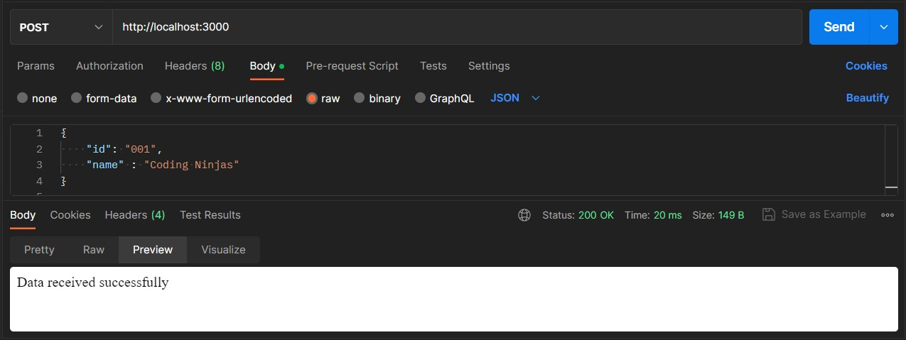

VS Code Terminal after POST request:

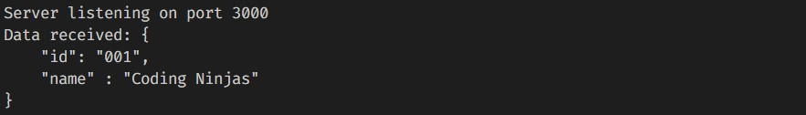

Code Example:

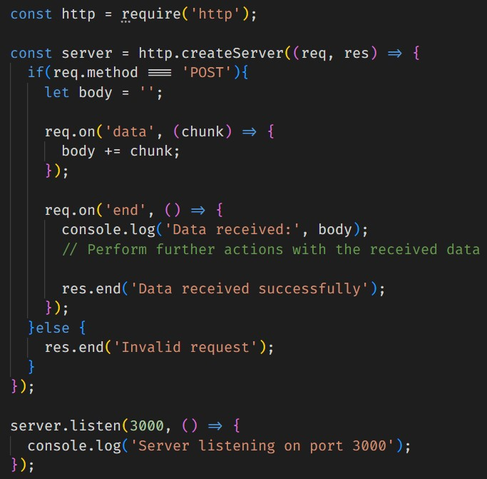

In the provided code example, we create an HTTP server using the built-in http module in Node.js. The server listens for incoming requests and specifically handles POST requests. When a POST request is received, the server appends the received data chunks and logs the complete data in the 'end' event callback. Further actions can be performed with the received data. The server responds back to the client indicating the successful reception of data.

# Creating Custom Events in Node.js

Custom events in Node.js allow developers to define and use their own events in applications, providing flexibility and control over event-driven functionality.

To create custom events, the 'events' module in Node.js provides the EventEmitter class, which serves as the foundation for working with events.

Example: Creating a custom event for an online store

1. Create a file called order-events.js and add the following code:

|  |
| --- |
| const EventEmitter = require('events'); |
|  |
| class Order extends EventEmitter { |
| placeOrder(orderData) { |
|  |
| // Emit the 'orderPlaced' event |
| this.emit('orderPlaced', orderData); |
| } |
| } |
| module.exports = Order; |

1. Create a file called index.js and add the following code:

|  |
| --- |
| const Order = require('./order-events'); |
|  |
| // Create an instance of the Order class |
| const order = new Order(); |
|  |
| // Listener for sending a confirmation email |
| const emailListener = (orderData) => { |
| console.log('Confirmation email sent:', orderData); |
| }; |
|  |
| // Listener for updating the inventory |
| const inventoryListener = (orderData) => { |
| console.log('Inventory updated for order:', orderData); |
| }; |
| // Add listeners to the 'orderPlaced' event using addListener() |
| order.addListener('orderPlaced', emailListener); |
| order.addListener('orderPlaced', inventoryListener); |
|  |
| // Simulate placing an order |
| order.placeOrder({ orderId: 123, |
| products: ['Product A', 'Product B'], |
| total: 100 |
| }); |

In this example, we create a custom event by extending the EventEmitter class with the Order class. The placeOrder method simulates placing an order and emits an 'orderPlaced' event with the order data. We use the addListener() method to add listeners for the 'orderPlaced' event. We define separate listener functions emailListener and inventoryListener for sending a confirmation email and updating the inventory, respectively.

1. When running the index.js file, the output will be:



# Event-Driven Architecture in Node.js

* Event-Driven Architecture is a core concept in Node.js that allows the flow of a program to be determined by events triggered by external factors or other parts of the application. External factors in Event-Driven Architecture could include user interactions (such as mouse clicks and keyboard inputs), network events (such as receiving a message from a server), or system events (such as the creation or modification of a file).
* In this architecture, events are emitted and event listeners react to those events, enabling concurrent and asynchronous handling of tasks.
* The main components of Event-Driven Architecture are events, event emitters, and event listeners.
* When an event occurs, all registered listeners for that event are executed independently.

## Example: Social media platform using Event-Driven Architecture

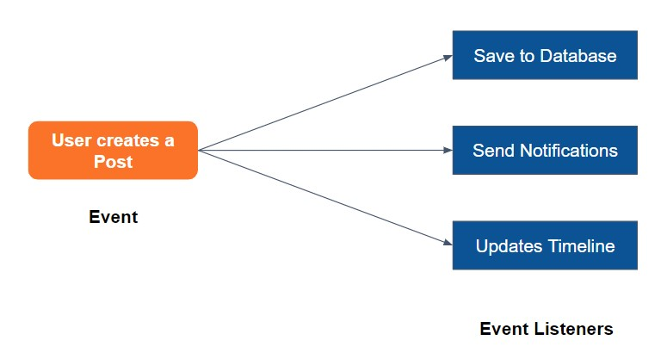

* In a social media platform, when a user creates a new post, multiple tasks need to be performed concurrently.
* By emitting a "postCreated" event, different listeners can react to the event and handle tasks independently.
* Example listeners include sending notifications to followers, updating the user's timeline, and saving the post to the database.

**Advantages of Event-Driven Architecture:**

1. Scalability: Supports handling a large number of simultaneous tasks, making it suitable for scalable applications.
2. Loose coupling: Components of the application are less dependent on each other, resulting in more maintainable and flexible code.
3. Better responsiveness: Concurrent and asynchronous handling of tasks ensures the application remains responsive even with a high volume of requests.
4. Improved performance: Efficient resource management and concurrent handling of multiple tasks lead to improved overall performance.

**Other real-world use cases for Event-Driven Architecture**

Stock trading application: Events like stock price changes can trigger actions such as user notifications, updating trading strategies, and logging historical data.

# Best Practices for Working with Modules in Node.js

Best practices are important for working with modules and writing maintainable code in Node.js. Following these practices ensures a clean and organized codebase, making development and collaboration more efficient.

**Organizing Code into Modules:**

Identify components in your application that can be modularized, such as user authentication, product management, shopping cart, and order processing.

Modularizing code improves maintainability, reusability, and separation of concerns.

**Naming Conventions:**

Use clear and descriptive names for variables, functions, and modules. Follow a consistent naming convention throughout the codebase for easier readability and understanding.

**Documentation:**

Document your code with comments to explain the purpose of functions and complex code blocks. Write a README file for each module, providing information about its functionality and usage. Documentation helps developers understand the codebase and facilitates future maintenance and collaboration.

**Version Control:**

Utilize version control systems like Git to track code changes and collaborate effectively. Use branches and pull requests to maintain a structured development process and ensure code integrity.

# Summarising it

Let’s summarise what we have learned in this module:

* Learned about debugging in Node.js.
* Learned about debugging in Visual Studio Code.
* Explored sending emails in Node.js.
* Studied events in Node.js and how to work with built-in and custom events.
* Learned how to test APIs using Postman.
* Created custom events in Node.js using the events module.
* Explored the advantages of using Event-Driven Architecture in Node.js applications.
* Discussed best practices for working with modules and writing maintainable code in Node.js.

**Some Additional Resources:**

* [**How**](https://www.digitalocean.com/community/tutorials/how-to-debug-node-js-with-the-built-in-debugger-and-chrome-devtools)[**To**](https://www.digitalocean.com/community/tutorials/how-to-debug-node-js-with-the-built-in-debugger-and-chrome-devtools)[**Debug**](https://www.digitalocean.com/community/tutorials/how-to-debug-node-js-with-the-built-in-debugger-and-chrome-devtools)[**Node.js**](https://www.digitalocean.com/community/tutorials/how-to-debug-node-js-with-the-built-in-debugger-and-chrome-devtools)[**with**](https://www.digitalocean.com/community/tutorials/how-to-debug-node-js-with-the-built-in-debugger-and-chrome-devtools)[**the**](https://www.digitalocean.com/community/tutorials/how-to-debug-node-js-with-the-built-in-debugger-and-chrome-devtools)[**Built-In**](https://www.digitalocean.com/community/tutorials/how-to-debug-node-js-with-the-built-in-debugger-and-chrome-devtools)[**Debugger?**](https://www.digitalocean.com/community/tutorials/how-to-debug-node-js-with-the-built-in-debugger-and-chrome-devtools)
* [**How**](https://miracleio.me/snippets/use-gmail-with-nodemailer/)[**to**](https://miracleio.me/snippets/use-gmail-with-nodemailer/)[**use**](https://miracleio.me/snippets/use-gmail-with-nodemailer/)[**nodemailer?**](https://miracleio.me/snippets/use-gmail-with-nodemailer/)
* [**How**](https://www.freecodecamp.org/news/how-to-code-your-own-event-emitter-in-node-js-a-step-by-step-guide-e13b7e7908e1/)[**to**](https://www.freecodecamp.org/news/how-to-code-your-own-event-emitter-in-node-js-a-step-by-step-guide-e13b7e7908e1/)[**code**](https://www.freecodecamp.org/news/how-to-code-your-own-event-emitter-in-node-js-a-step-by-step-guide-e13b7e7908e1/)[**your**](https://www.freecodecamp.org/news/how-to-code-your-own-event-emitter-in-node-js-a-step-by-step-guide-e13b7e7908e1/)[**own**](https://www.freecodecamp.org/news/how-to-code-your-own-event-emitter-in-node-js-a-step-by-step-guide-e13b7e7908e1/)[**event**](https://www.freecodecamp.org/news/how-to-code-your-own-event-emitter-in-node-js-a-step-by-step-guide-e13b7e7908e1/)[**emitter**](https://www.freecodecamp.org/news/how-to-code-your-own-event-emitter-in-node-js-a-step-by-step-guide-e13b7e7908e1/)[**in**](https://www.freecodecamp.org/news/how-to-code-your-own-event-emitter-in-node-js-a-step-by-step-guide-e13b7e7908e1/)[**Node.js?**](https://www.freecodecamp.org/news/how-to-code-your-own-event-emitter-in-node-js-a-step-by-step-guide-e13b7e7908e1/)
* [**Postman**](https://www.guru99.com/postman-tutorial.html)[**Tutorial**](https://www.guru99.com/postman-tutorial.html)[**–**](https://www.guru99.com/postman-tutorial.html)[**How**](https://www.guru99.com/postman-tutorial.html)[**to**](https://www.guru99.com/postman-tutorial.html)[**use**](https://www.guru99.com/postman-tutorial.html)[**for**](https://www.guru99.com/postman-tutorial.html)[**API**](https://www.guru99.com/postman-tutorial.html)[**Testing?**](https://www.guru99.com/postman-tutorial.html)